What is SDLC?

**Explain SDLC Model: -**

* SDLC is a structured process that enable the production high quality, low cost software in a shortest possible production time.
  + SDLC Is Software Development Life Cycle
  + How to Developed Software In IT Company/ Process of developing software in Company

Write SDLC phase with basic introduction?

1. **Requirement Analysis**
2. **Planning**
3. **Architecture Design**
4. **Implementation/Development**
5. **Software Testing**
6. **Deployment**
7. **Maintenance**

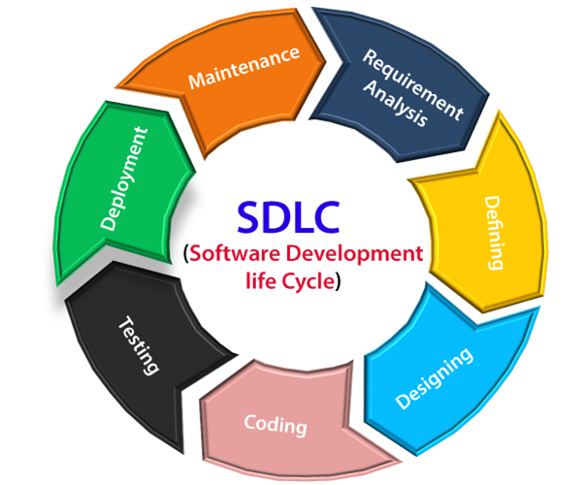

* *“A SDLC is a series of steps, or phases, that provide a model for the development and lifecycle management of an application or piece of software.”*

1. **Requirement Analysis: -**
   * + Feature
     + Although Requirements may be documented in written form, they may be incomplete, or even incorrect.
     + Requirement will change!!
       - Three types of problem can arise:
         * **Lack of Clarity:** It is hard to write document that are both precise and easy to read.
         * **Requirements confusion:** Functional and Non-Functional requirements tend to be intertwined.
         * **Requirements Amalgamation:** several different requirement may be expressed.

* **There are two types of Requirement: -**
  1. **Functional Requirements (It’s Provided by client)**
     + Describe system service or functions.
     + Compute sales tax on a purchase
     + Update the database on the server
  2. **Non-Functional Requirements (it’s based on developer Knowledge)**
     + Are constraints on the system or the development process
     + It is more critical than functional requirements
     + If these are not met, the system is useless!
* **Functional Requirement for WhatsApp: -** 
  + Login page(with mobile number)
  + User registration
  + Last seen
  + Send message/receive message
  + Scan QR code
  + Camera
  + Adding new contacts
  + Send attachments (photo, video, contact, document, location, audio, poll of question)
  + Message status
  + Broadcast message
  + End to end encryption
  + Voice and video call
  + User banning and reporting
  + Notification
* **Non-Functional Requirements for WhatsApp: -**
  + Privacy
  + Scalability
  + Robustness
  + Performance
  + Attractive UI
  + Security
* **Functional Requirement for Flipkart Shopping App: -**
  + Login page
  + User sing-in & log-in page
  + New user registration
  + Adding new feature and updates
  + Add to cart, payment option
  + Search bar
  + Filter items
  + Offers and discount for individual user
  + Track delivery like conformation of order, dispatch item, ready to shipment, etc.
* **Non-Functional Requirement: -**
  + Privacy
  + Security
  + Attractive UI
  + Performance
  + Scalability
  + Robustness

1. **Planning: -**
   * The planning phase define the requirement of the system, independent of how these requirement will be accomplished.
   * The deliverable result at the end of the phase is a requirement document.

* **That written document is called as SRS (Software Requirement Specification)**
  + Ideally, this document states in a clear and precise fashion what is to be built.

1. **Architecture Design: -**
   * This phase starts with the requirement document deliverable by the requirement phase and maps the requirement into architecture.
   * The architecture define the component, their interface and behaviours.
   * The deliverable design document is the architecture.
   * Details on computer programming languages and environments, machines, packages, application architecture, distributed architecture layering, memory size, platform, algorithms, data structures, global type definitions, interfaces, and many other engineering details are established.
   * The architecture team also converts the typical scenarios into a test plan.
   * There are two types of design: -
     1. High level design
     2. Low level design
2. **Implementation/Development: -**
   * Given the architecture document from the architecture design phase and the requirement document from the requirement phase, the team should build exactly what has been requested, though there is still room for innovation and flexibility.
   * Implementation software
   * Coding phase
   * Build software
   * It is a longest phase of the SDLC process.
   * Helping tools: - compiler, interpreter, debugger.
3. **Software Testing: -**
   * Simply started, Quality is very important.
   * There is merit in this approach; it is hard to see one’s own mistakes, and a fresh eye can discover obvious errors much faster than the person who has read and re-read the material many times.
   * These are the some technique example: -
     1. Regression Testing
     2. Internal Testing
     3. Unit Testing
     4. Application Testing
     5. Stress Testing
4. **Deployment: -**
   * Once the product is tested and ready to be deployed it is released formally in the appropriate market.
   * Sometimes product deployment happens in a stage as per the business strategy of that organization.
   * The product may first be released in a limited segment and tested version (**UAT**- user acceptance testing).
   * Usually, that segment or version is called ß- version or ß- testin**g**
5. **Maintenance: -**
   * Maintenance include software upgrades, repairs, and fixes of the software breaks.
   * Monitoring the performance of the software is also include during the maintenance phase.
   * It allows the customer to request for upgrades and get the fixes patches for problem internally or externally identified.

* **There are three types of maintenance: -**

1. **Corrective maintenance** (Bug fixing): identifying and repairing defects.
2. **Adaptive maintenance** (Upgrade): adapting the existing solution to the new platforms.
3. **Perfective maintenance** (enhancement): implementing the new requirements.

What is software testing?

1. **Introduction of Software: -**
   * Software is a set of Instruction, Data or Program used to Operate Computers and Execute specific tasks.
2. **What Is Testing: -**
   * Testing is executing a system in order to identify any gapes, errors or missing requirements in contrary to the actual desire or requirements.
   * According to ANSI/IEEE 1059, process of analysing a software item to detect the difference between existing and required conditions.
   * Software Testing is a process used to identify the correctness, completeness, quality of developed computer software.
   * It can also be a started as the process of validating and verifying.

What is SRS?

* The deliverable result at the end of the phase is a requirement document.
* **That written document is called as SRS (Software Requirement Specification)**
* Ideally, this document states in a clear and precise fashion what is to be built.

Explain water fall model phases?

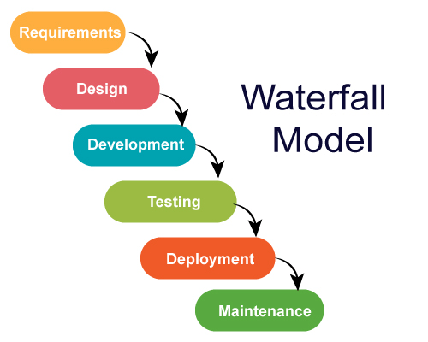

* **Requirement Gathering and analysis** − All possible requirements of the system to be developed are captured in this phase and documented in a requirement specification document.
* **System Design** − the requirement specifications from first phase are studied in this phase and the system design is prepared. This system design helps in specifying hardware and system requirements and helps in defining the overall system architecture.
* **Implementation** − with inputs from the system design, the system is first developed in small programs called units, which are integrated in the next phase. Each unit is developed and tested for its functionality, which is referred to as Unit Testing.
* **Integration and Testing** − All the units developed in the implementation phase are integrated into a system after testing of each unit. Post integration the entire system is tested for any faults and failures.
* **Deployment of system** − Once the functional and non-functional testing is done; the product is deployed in the customer environment or released into the market.
* **Maintenance** − There are some issues which come up in the client environment. To fix those issues, patches are released. Also to enhance the product some better versions are released. Maintenance is done to deliver these changes in the customer environment.

Draw use-case on Online shopping product using payment gateway

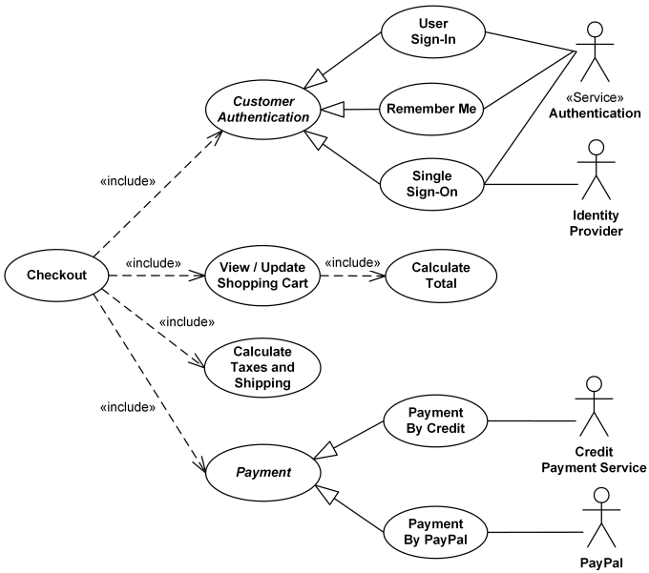

Draw use-case on Online shopping product using COD.

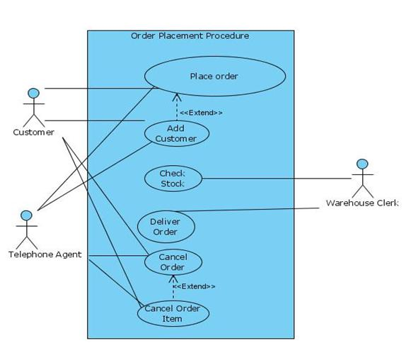

Explain working methodology of agile model and also write pros and cons.

**Agile model: -**

* + Agile SDLC model is a combination of iterative and incremental process model with focus on process adaptability and customer satisfaction by rapid delivery of working software product.
  + Agile method break the product into small incremental builds.
  + These builds are provided in iterations.
  + Each iteration typically lasts from about one to three weeks.
  + Every iteration involves cross function teams working. Simultaneously on various areas like planning, requirements analysis, design, coding, unit testing, and acceptance testing.
  + At the end of the iteration a working product is displayed to the customer and important stakeholders.
  + Agile model believes that every project needs to be handled differently and the existing methods need to be tailored to best suit the project requirements. In agile the tasks are divided to time boxes (small time frames) to deliver specific features for a release.
  + Iterative approach is taken and working software build is delivered after each iteration. Each build is incremental in terms of features; the final build holds all the features required by the customer.
  + Agile thought process had started early in the software development and started becoming popular with time due to its flexibility and adaptability.
    1. **Pros: -**
       - Is a very realistic approach to software development
       - Promotes teamwork and cross training.
       - Functionality can be developed rapidly and demonstrated.
       - Resource requirements are minimum.
       - Suitable for fixed or changing requirements
       - Delivers early partial working solutions.
       - Good model for environments that change steadily.
       - Minimal rules, documentations easily employed.
       - Enables concurrent development and delivery within an overall planned context.
       - Little or no planning required.
       - Easy to manage.
       - Gives flexibility to developers.
    2. **Cons: -**
       - Not suitable for handling complex dependencies.
       - More risk of sustainability, maintainability and extensibility.
       - An overall plan, an agile leader and agile PM practice is must without which it will not work.
       - Strict delivery management dictates the scope, functionality to be delivered, and adjustment to meet the deadlines.
       - Depends heavily on customer interaction, so if customer is not clear, team can be driven in the wrong direction.
       - There is very high individual dependency, since there is minimum documentation generated.
       - Transfer of technology to new team members may be quite challenging due to back documentation.

Write phases of spiral model

**1. Planning**

* This phase begins by gathering business requirements into a baseline spiral. In the subsequent spiral as the product matures, all system, subsystem and unit requirements are identified at this stage.
* This phase also includes understanding system requirements through ongoing communication between the customer and system analysts. At the end of the spiral, the product will be deployed in the identified market. This includes iteration cost, schedule, and resource estimates. This includes understanding system requirements for ongoing communication between system analysts and customers.

**2. Risk Analysis**

* After the “plan” phase, the team prepares for the “risk” phase. The “risk” phase is designed to take into account the variability in the rate at which a given product might fail. It is designed to account for the uncertainty in the rate at which a given product might fail. During the “risk” phase, the team evaluates various aspects of the current state of the product, such as the state of its code, the state of its design, and the state of its prototype. The team then makes adjustments to the current state of the product based on the changes made in the “plan” phase, and then follows up with a “sales” phase to collect customer feedback.
* Once risks are identified, risk mitigation strategies are planned and completed.
* Briefly, risk analysis involves identifying, estimating and monitoring technical feasibility and management risks such as: schedule slippage and cost overrun. After testing the build, at the end of the first iteration, customers rate the software and provide feedback.

**3. Product development**

* In the next quadrant, prototypes are built and tested. This step includes architectural design, module design, physical product design and final design. Convert the proposals made in the first two quadrants into usable software.
* This phase also includes the actual implementation of features in a project which are verified by performing testing.

4. **Next phase planning**

* In this phase, the software is evaluated by the customer and feedback is given. The team prepares for the next phase of the planning process. The next phase of the planning process is known as the “spiral” phase. During the “spiral” phase, the team determines the order of events in the current state of the product and then follows these events up with a “revision” phase to “Revise” the current state of the product so that it is ready for production. The “revision” phase is also called the “reproduction” phase, and it is one of the most important aspects of the planning process.

Draw Use-case on online bill payment system (paytm)

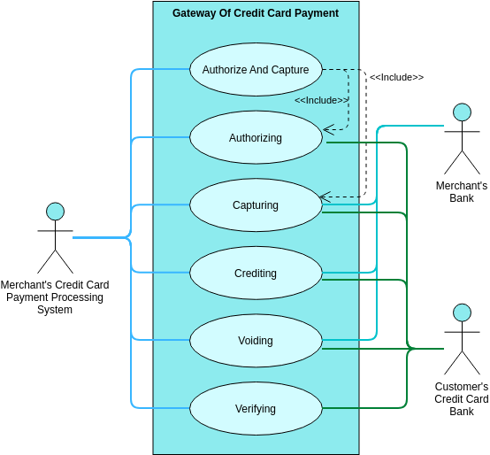

Draw Use-case on online book shopping

